Nombre_____________________________________ Clase________ Fecha________

Fall 2018 Spanish 1 Final Exam
Las preguntas de la entrevista

You should be prepared to answer 4 of these questions in Spanish (2 from the top section, and 2 from the bottom section). You will not be able to see or read the questions during your exam—you will need to understand what your teacher is saying to you. To receive full credit, you must answer in a complete sentence, with a logical and grammatically correct response.

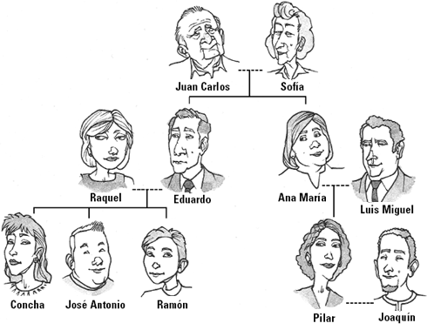
- ¿Quién es tu pariente favorito? y ¿Cómo es él o ella? (2 details)
- ¿Cuántos años tienes?
- ¿Cuál es tu clase favorita y ¿Por qué?
- Describe 2 relaciones diferentes entre los miembros de la
familia en la foto.
a.
b.

- ¿Qué te gusta hacer los fines de semana?
- ¿Cómo eres (3 details)?
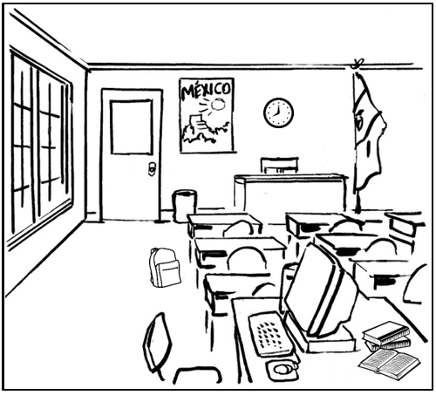
1. ¿Qué haces en tu tiempo libre?
2. ¿De dónde eres?
3. Describe dónde están 2 objetos en la foto
(use estar & prepositions of location)

4. ¿Qué haces en la clase de español?
5. ¿Qué comes en el desayuno o el almuerzo?
6. ¿Cómo estás hoy?
Speaking Final Exam – Spanish 1 NAME:_________________________________

COMPREHENSION (POOR) 1 2 3 4 5 (EXCELLENT)
(ability to understand
oral cues and respond
appropriately)

COMPREHENSIBILITY (POOR) 1 2 3 4 5 (EXCELLENT)
(ability to communicate
ideas and be understood)

ACCURACY (POOR) 1 2 3 4 5 (EXCELLENT)
(ability to use structures and
vocabulary correctly)

FLUENCY (POOR) 1 2 3 4 5 (EXCELLENT)
(ability to communicate
clearly and smoothly)
EFFORT (POOR) 1 2 3 4 5 (EXCELLENT)
(inclusion of details beyond the
minimum predictable response)

TOTAL POINTS /25

REST OF THE YEAR CALENDAR
Monday | Tuesday | Wednesday | Thursday | Friday
13 | 14 | 15 | 16 | 17
Finish up the unit Ch. 4/5  Play review games | Final Quiz – Stem-changers, places, -GO Verbs  Students begin working on their Sp. 1 Review Folders | Students continue/finish working on their Sp. 1 Review Folders | Food Day! | Writing Portion of the Final  Start Speaking Portion of Final Exam
20 | 21 | 22 | 23 | 24
Listening Portion of Final Exam  Finish Speaking Portion | Final Exam – 1st and 2nd blocks (Multiple Choice) | Final Exam – 3rd and 4th blocks (Multiple Choice)

